MCA Part 1

Paper 2: Computer Organisation

Prepared by : Dr. Kiran Pandey

School of Computer Science

Email-id: kiranpandey.nou@gmail.com

Lecture-02

Binary Arithmetic

1’s complement and 2’s complement
Complements are used in the digital computers in order to simplify the subtraction operation and for the logical manipulations. For each radix-r system (radix r represents base of number system) there are two types of complements.
S.N. | Complement | Description
1 | Radix Complement | The radix complement is referred to as the r's complement
2 | Diminished Radix Complement | The diminished radix complement is referred to as the (r-1)'s complement

As the binary system has base r = 2. So the two types of complements for the binary system are 2's complement and 1's complement.

1's complement
The 1's complement of a number is found by changing all 1's to 0's and all 0's to 1's. This is called as taking complement or 1's complement. Example of 1's Complement is as follows.
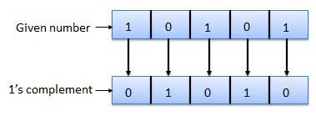

2's complement
The 2's complement of binary number is obtained by adding 1 to the Least Significant Bit (LSB) of 1's complement of the number.
2's complement = 1's complement + 1
Example of 2's Complement is as follows.

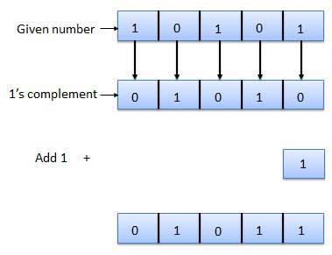
Binary arithmetic is essential part of all the digital computers and many other digital system.

Binary Addition
It is a key for binary subtraction, multiplication, division. There are four rules of binary addition.
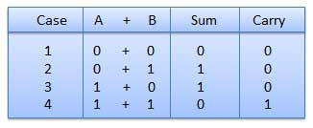
In fourth case, a binary addition is creating a sum of (1 + 1 = 10) i.e. 0 is written in the given column and a carry of 1 over to the next column.

Example − Addition
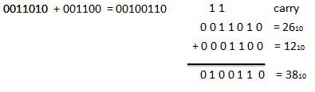

Binary Subtraction
Subtraction and Borrow, these two words will be used very frequently for the binary subtraction. There are four rules of binary subtraction.
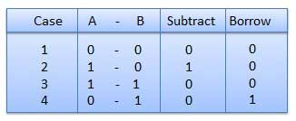

Example − Subtraction
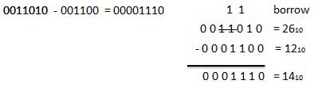

Binary Multiplication
Binary multiplication is similar to decimal multiplication. It is simpler than decimal multiplication because only 0s and 1s are involved. There are four rules of binary multiplication.
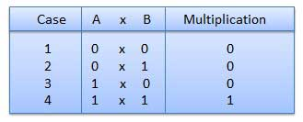

Example − Multiplication
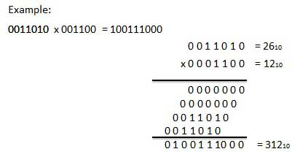

Binary Division
Binary division is similar to decimal division. It is called as the long division procedure.

Example − Division
