Prof N.P.Tiwary For Students of B.Sc, Zoology, Part III, Paper VI.
Co-ordinator Zoology
N.O.U, Patna.
Passive and Active Transport
All cells are generally separated from their surrounding environment by plasma membrane the cell membrane has the ability to regulate the concentration of substances inside the cell. These substances include ions such as Ca²⁺, Na⁺, K⁺, and Cl–; nutrients including sugars, fatty acids, and amino acids; and waste products, particularly carbon dioxide (CO₂), which must leave the cell.
The membrane’s lipid bilayer structure provides the first level of control. The phospholipids are tightly packed together, and the membrane has a hydrophobic interior. This structure causes the membrane to be selectively permeable. A membrane that has selective permeability allows only substances meeting certain criteria to pass through it unaided. In the case of the cell membrane, only relatively small, nonpolar materials can move through the lipid bilayer All substances that move through the membrane do so by one of two general methods, which are categorized based on whether or not the transport process is exergonic or endergonic.
Passive transport is the exergonic movement of substances across the membrane.
Active transport is the endergonic movement of substances across the membrane that is coupled to an exergonic reaction.
Types of transport process: Two types of transport process occur across the membrane.
1. Non-mediated transport : It occurs through the simple diffusion process and the driving force for the transport of a substance through a medium depends on its chemical potential gradient.
2. Mediated transport
a. Passive mediated transport or facilitated diffusion: In this type of process a specific molecule flows from high concentration to low concentration. Substances that are too large or polar diffuse across the lipid bilayer on their own through membrane proteins called carriers, permeases, channels and transporters. Unlike active transport, this process does not involve chemical energy. So the passive mediated transport is totally dependent upon the permeability nature of cell membrane, which in turn, is function of organization and characteristics of membrane lipids and proteins.
b. Active transport: In this type of process a specific molecule is transported from low concentration to high concentration, that is, against its concentration gradient

Types of passive transport:
Diffusion: The process of the net movement of solutes from a region of high concentration to a region of low concentration is known as diffusion. The differences of concentration between the two regions are termed as concentration gradient and the diffusion continues till the gradient has been vanished. Diffusion occurs down the concentration gradient.
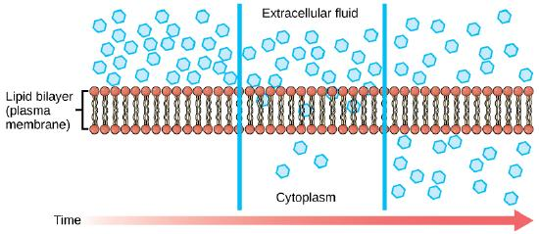
2. Osmosis: Osmosis is the type of diffusion of water molecules across a semi- permeable membrane, from a solution of high water potential to a region of low water potential. A cell with a less negative water potential will draw in water but this depends on other factors as well such as solute potential (pressure in the cell e.g. solute molecules) and pressure potential (external pressure e.g. cell wall).
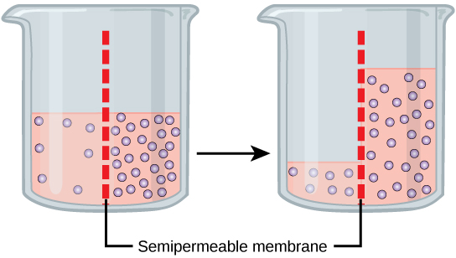
3. Filtration: Filtration is the process of the movement of water and solute molecules across the cell membrane due to hydrostatic pressure generated by the system. Depending on the size of the membrane pores, only solutes of a certain size may pass through it. The membrane pores of the Bowman's capsule in the kidneys are very small, and only albumins (smallest of the proteins)can filter through. On the other hand, the membrane pores of liver cells are extremely large, to allow a variety of solutes to pass through and be metabolized.
Passive mediated transport or facilitated diffusion:
2. Facilitated diffusion : The process of the movement of molecules across the cell membrane via special transport proteins that are embedded within the cellular membrane is known as facilitated diffusion or called carrier-mediated diffusion. A concentration gradient exists that allows these materials to diffuse into or out of the cell without expending cellular energy Many large molecules, such as glucose, are insoluble in lipids and too large to fit into the porins, therefore, it will bind with its specific carrier proteins, and the complex will then be bonded to a receptor site and moved through the cellular membrane.
Channels
The integral proteins involved in facilitated transport are collectively referred to as transport proteins, and they function as either channels for the material or carriers. In both cases, they are transmembrane proteins. Different channel proteins have different transport properties. Some have evolved to be have very high specificity for the substance that is being transported while others transport a variety of molecules sharing some common characteristic(s).
Passage through the channel allows polar compounds to avoid the nonpolar central layer of the plasma membrane that would otherwise slow or prevent their entry into the cell.
A special class of membrane proteins called aquaporins is present that allow water to pass through the membrane at a very high rate.
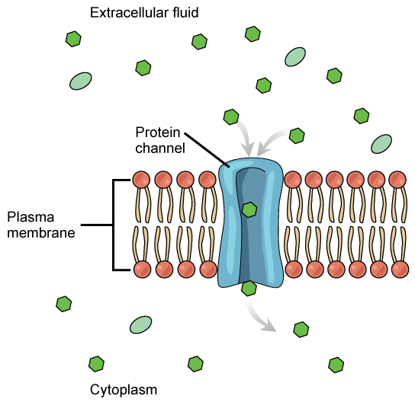

Carrier Proteins
Another type of protein embedded in the plasma membrane is a carrier protein. This aptly named protein binds a substance and, in doing so, triggers a change of its own shape, moving the bound molecule from the outside of the cell to its interior; depending on the gradient, the material may move in the opposite direction. Carrier proteins are typically specific for a single substance. This selectivity adds to the overall selectivity of the plasma membrane. The molecular-scale mechanism of function for these proteins remains poorly understood.
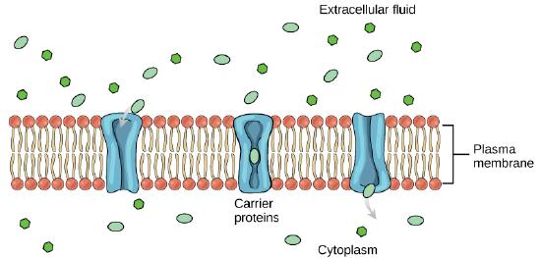
Carrier proteins play an important role in the function of kidneys. Glucose, water, salts, ions, and amino acids needed by the body are filtered in one part of the kidney. This filtrate, which includes glucose, is then reabsorbed in another part of the kidney with the help of carrier proteins.
Channel and carrier proteins transport materials at different rates. Channel proteins transport much more quickly than do carrier proteins. Channel proteins facilitate diffusion at a rate of tens of millions of molecules per second, whereas carrier proteins work at a rate of a thousand to a million molecules per second.

Active transport: In active transport substances move against the concentration gradient. Among the substances which use active transport are ions such as Na+ and H+, six carbon sugar like glucose and amino acids. In active transport a substance can continue to accumulate in a region where it already exists in higher concentrations. This is done when energy for metabolism is constantly supplied to the carrier system.
Characteristics of active transport:
- Active transport goes against gradients of chemical or electrical potentials.
- It requires metabolic energy and is sensitive to metabolic poisonIt is dependant 0n the presence and activities of membrane proteins
- It shows specificity that is only a certain molecules or group of molecules is moved across membranes by a given active transport.
They show several characteristics of facilitated diffusion and has active sites which binds the transported molecules.
Types of active transport: Two mechanisms exist for the transport of small-molecular weight material and small molecules. . .
a. which is directly dependant on ATP hydrolysis; Primary active transport
b. which is indirectly dependant ; secondary active transport
- Primary active transport:Primary active transport, also called direct active transport, directly uses energy to transport molecules across a membrane. Example:Sodium-potassium pump, which helps to maintain the cell potent
Primary active transport moves ions across a membrane and creates a difference in charge across that membrane, which is directly dependent on ATP
- Secondary active transport:Secondary active transport or co-transport, also uses energy to transport molecules across a membrane; however, in contrast to primary active transport, there is no direct coupling of ATP; instead, the electrochemical potential difference created by pumping ions out of the cell is instrumental.

Carrier Proteins for Active Transport
An important membrane adaption for active transport is the presence of specific carrier proteins or pumps to facilitate movement: there are three types of these proteins or transporters.
- A uniporter carries one specific ion or molecule.
- A symporter carries two different ions or molecules, both in the same direction. Symport uses the downhill movement of one solute species from high to low concentration to move another molecule uphill from low concentration to high concentration (against its electrochemical gradient).
- An antiporter : In antiport two species of ion or solutes are pumped in opposite directions across a membrane. One of these species is allowed to flow from high to low concentration which yields the entropic energy to drive the transport of the other solute from a low concentration region to a high one.Example: the sodium-calcium exchanger or antiporter, which allows three sodium ions into the cell to transport one calcium out.
All of these transporters can also transport small, uncharged organic molecules like glucose. These three types of carrier proteins are also found in facilitated diffusion, but they do not require ATP to work in that process.
Some examples of pumps for active transport are Na⁺-K⁺ ATPase, which carries sodium and potassium ions, and H⁺-K⁺ ATPase, which carries hydrogen and potassium ions. Both of these are antiporter carrier proteins. Two other carrier proteins are Ca²⁺ ATPase and H⁺ ATPase, which carry only calcium and only hydrogen ions, respectively. Both are pumps.

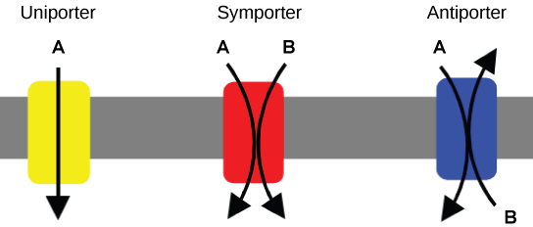
n primary active transport, the energy is derived directly from the breakdown of ATP. Often times, primary active transport such as that shown below which functions to transport sodium and potassium ions allows secondary active transport to occur (discussed in the section below). The second transport method is still considered active because it depends on the use of energy from the primary transport.
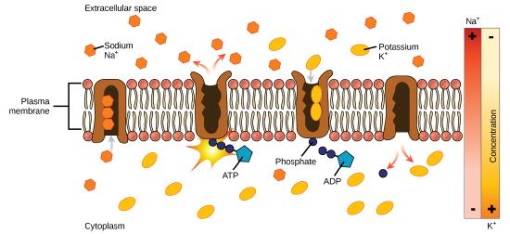
Figure 10: Primary active transport moves ions across a membrane, creating an electrochemical gradient (electrogenic transport). (credit: modification of work by Mariana Ruiz Villareal)

Active transport Pumps:
P- type dsirect active transport pumps: The p type transporters are the most well known of all the direct active transport pumps. The pump temporarily binds a phosphate group removed from ATP during the pumping cycle. The name P- type comes from their binding of a phosphate (P)
Three most familiar P – type pumps are:
- H+ ATP ase pumps: this actively moves hydrogen out of the cell. This pump functions in the following ways:
- At first the transporters is folded so that H+ binding site faces the inside of the cell.
- The pump binds and hydrolyses the ATP. Terminal phosphate is transferred and covalently attached to the transporter and forms a high energy complex
- This attachment converts H+ binding site to high affinity state thus H+ binds readily colloiding with the transporter on the cytoplasmic side of the membrane. Now confirmation changes from high to low and H+ is released to outside even though the outside concentration of H+ is high.
- The phosphate group is released at the same timeand this along with released H+ ion indicates a final confirmation change which returns the protein to initial conformation.
- These pumps can be mde to synthesize ATP by forcing them to run in reverse.
- Ca ++ ATP ase pumps:
- This hydrolyses ATP to move Ca++ against its concentration gradients out of cells or into cytoplasmic vesicles like those in ER
- The gradients that results from the activity of these pumps are used as a controller of cellular activities like muscle contraction, secretion and microtubule assembly. The controlled activities are triggered by a sudden release of Ca++ into the cytoplasm
- Sodium-potassium pump (Na⁺-K⁺ ATPase): One of the most important pumps in animal cells which maintains the electrochemical gradient (and the correct concentrations of Na⁺ and K⁺) in living cells. The sodium-potassium pump moves K⁺ into the cell while moving Na⁺ out at the same time, at a ratio of three Na⁺ for every two K⁺ ions moved in. The Na⁺-K⁺ ATPase exists in two forms, depending on its orientation to the interior or exterior of the cell and its affinity for either sodium or potassium ions. The process consists of the following six steps.
- With the enzyme oriented towards the interior of the cell, the carrier has a high affinity for sodium ions. Three ions bind to the protein.
- ATP is hydrolyzed by the protein carrier and a low-energy phosphate group attaches to it.
- As a result, the carrier changes shape and re-orient itself towards the exterior of the membrane. The protein’s affinity for sodium decreases and the three sodium ions leave the carrier.
- The shape change increases the carrier’s affinity for potassium ions, and two such ions attach to the protein. Subsequently, the low-energy phosphate group detaches from the carrier.
- With the phosphate group removed and potassium ions attached, the carrier protein repositions itself towards the interior of the cell.
- The carrier protein, in its new configuration, has a decreased affinity for potassium, and the two ions are released into the cytoplasm. The protein now has a higher affinity for sodium ions, and the process starts again.
Membrane Potential: Due to unequal number of positive charge that move inward and outward by Na+/K+ ATP-ase pump across the membrane sets up a difference in voltage or electrical potential across the membrane of all animal cells. This is called the membrane potential. It varies from 20-200 mV and is always negative inside the cell. In most cells the Na+ K+ pump runs continuously and uses 80% of the cell energy. Active transport will stop if the cellular respiration stops as there will be no energy.
V -Type Active transport Pumps: The V type (Vesicle)( pump have been detected in the membrane of internal structures like Golgi complex and lysosomes. These directly use ATP without the release of phosphate group.
Indirect active transport: In indirect transport a concentration gradient which is maintained by active transport of an ion serves as the energy source which drives the active transport of another substance. Since molecules are carried in or out of cells by indirect active transport it always moves across membrane in conjunction with an ion that supplies the driving force the pathway of active transport is called contrasport.

